Corpus Christi
May 29 - 2016 Year "C"
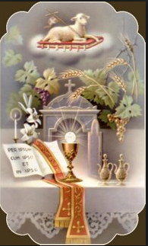
"As often as you eat this bread and drink the cup, you proclaim the Lord's death until he comes." 1 Corinthians 11.23-26

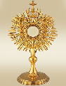
The feast is not only about the Eucharist - it is also about the community that assembles to celebrate the Eucharist. Hospitality is at the heart of the gospel message. If our hearts are not open and ready to share with those in need in our ordinary life we cannot be united in our celebration. There is no way we can offer the Eucharist and not reach out to the poor as Jesus did. It is the daily life that we live during the week that gives us something to bring to the community Mass on Sunday. We cannot take a worldly life-style to the altar and celebrate it as christians. By living lives of service for others, we begin to appreciate what the eucharist is all about. It sends us out to touch the lives of neighbours as the healing presence of a helping hand or a sympathetic voice, changing despair into hope and suspicion into trust.
One cannot be truly present at the Eucharist without a desire to change and set out on the road travelled by Christ, trying to live as he did in a caring and sharing way. Every celebration is an invitation to give ourselves as completely as possible to Jesus, and to surrender ourselves to his power of love, which will change us and bring us to eternal life. When we are deeply scarred by sin the eucharist binds up our wounds, restores our strength and pours peace into our troubled souls. The very fact that we celebrate this feast indicates that we are a people of thanksgiving, a community which knows how to praise God for the basic gifts of life, family, friends, food and clothing. Above all we thank God because of what he has done for us in Christ.
Working wonders people in our homes and parishes...
In 2012, Nadia was brought to street Haven's emergency shelter by the police. She was an immigrant and had been locked in a garage by her husband and mother-in-law for two years, rarely able to visit the two children. Upon her arrival at Street Haven, Nadia thrived. She slowly built trust with the counselors, participated in household responsibilities, and loved looking after the gardens. Her counselor set Nadia up with a lawyer and after a year of legal consultations, she received custody of her two children.
Street Haven helped them find housing and Nadia and her children now live in a beautiful, safe home where they have started a new chapter in their lives.
Next ShareLife Sunday is May 29.
Please give generously. You can work wonders!

The 2016 ShareLife Parish Campaign Goal:
$12.95 million (225 parishes)
1st Collection Total $13,850.00
2nd Collection April 17th $10,750.00
3rd Collection May 29th
Our Goal is $45,000.00
St. Clement Parish at 409 Markland Drive, invites you to drop in at their Adoration Chapel.
It is open daily from 6am to 12midnight.
You are also welcome to sign up as Permanent and/or Substitute adorers.
For more information, please call Elizabeth at 416-621-4060
Eucharist - by Pope Francis
Jesus, Bread of Eternal Life, came down from heaven and was made flesh thanks to the faith of Mary Most Holy. After having borne him with ineffable love in herself, she followed him faithfully unto the Cross and to the resurrection. Let us ask Our Lady to help us rediscover the beauty of the Eucharist and to make it the center of our life, especially at Sunday Mass and in adoration.
Angelus, June 22, 2014
Vocations - Ordination
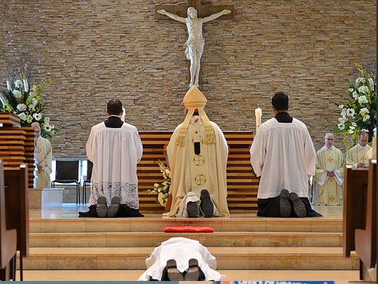
Let us pray for our newly ordained priests that Jesus will fill their hearts with faith, hope and love.
We pray to the Lord.
Jesus has given us His Body to eat and His Blood to drink so as to nourish us on our journey towards the Kingdom. May we be faithful to him on our journey as a married, single, ordained or consecrated person. If you think God is calling you to be a priest, religious or deacon,
contact Fr. Chris Lemieux, Vocation Director, Archdiocese of Toronto 416-968-0997
www.vocationstoronto.ca

PRAYER
O Virgin Mary, my Mother,
I give to your Immaculate Heart
my body and my soul,
my thoughts and my actions.
I want to be just what you want me to be,
and do just what you want me to do.
I am not afraid because you are always with me.
Help me to love your Son, Jesus,
with all my heart and above all things.
Take my hand in yours, so I can always be with you.
Amen.
The month of May is dedicated to Mother Mary.

Family Day -
June 25 after 4:30 p.m. Mass
Together with the K of C we will have a Barbeque for the family.
The Knights will be Barbequing and CWL will help to prepare the food.
This will also be an opportunity to celebrate Fr. Darrin's 20th Anniversary to Priesthood.
Tickets will be sold after all masses Jun 04 onwards.
Cost $10 and $5 for children.

Please come and let's have a fun filled day.

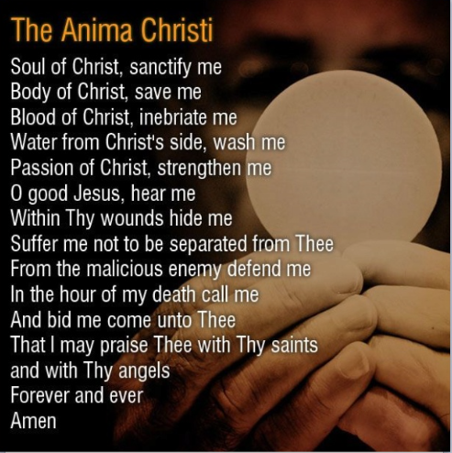

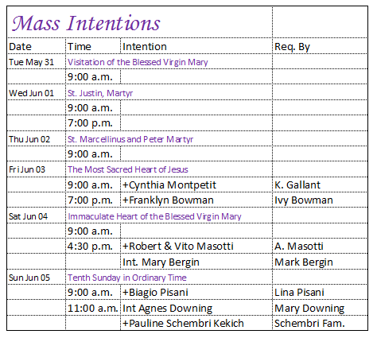
Pray for the sick of the parish, especially for:
Donna Wilson, Jane Murnaghan, Mary Bergin,
Gladys Smyth, Anne English, Anita Bergin, Viola McLaughlin, Ada Ottolino, Fred Micallef, Susie Zahra, Marcelle Caruana, Arduino Bonora, Maria Vella,. A. Matar.

To request a Mass :
simply phone the office and write all the particulars on an envelope and deposit separate from your weekly envelopes into the collection basket. Thank you.

