Holy Trinity Sunday
May 22- 2016 Year "C"
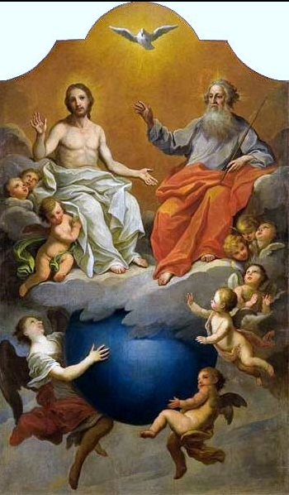
"All that the Father has is mine, and the Spirit will take what is mine and declare it to you." John 16.12-15
It may come as surprise to realise that Jesus gave us the command to love one another at the Last Supper shortly after Judas had left the upper room on his mission of betrayal. This was the new order the Saviour had come to bring, and the sign by which the world would recognise his followers. Christ paid a great price to love us. It meant crucifixion and death on the cross at Calvary. If we are to live by this new commandment we must undergo many trials, for this love makes as many demands upon us as it did upon Christ. We need to learn how to go about loving others for the sake of God because, in the evening of life, we will be judged on how well we have loved.
Christ's rule for living life properly may not present problems as far as loving our friends is concerned. Most of us are fairly good at overlooking their faults, making allowances for their shortcomings and forgiving their failures. It is easy to love those who are kind and loving towards us but christian love calls us to do more than this. Nobody must be excluded form our loving. What about our enemies - those who have done us harm and perhaps still do? We fail miserably when we retaliate and our good intentions are shattered as we gossip maliciously about them. The making of ourselves into real christians is the work of a lifetime. Conversion does not take place overnight and requires much patience.
The one thing we all need to experience is the kind of love that Jesus lived and preached. It's a love which finds its source in God, is a fragment of eternity withing our being and without which our lives have no meaning. This is the one Commandment on which we are called to base every action and it is the very core of the gospel. Love has the power to give meaning to impossible situations, to bring light into darkness, to inspire people, fill them with hope and give them the courage to continue on the road ahead. The Lord may not be walking our pathway today in his physical body but in every age he continues the work of making the whole of creation new through his disciples. The good news is that we have been chosen to be instruments of his grace, channels through which others may experience his love. It may simply be a smile which costs nothing but means so much, because it comes from our hert. In one sense the only failure facing any christian in life is the failure to love.
Working wonders for those who need help in our neighbourhood...
"I first came to Rose of Sharon as a pregnant, young mom, thinking this would never happen to me," explains Brittany, now with her five year old son Ethan and one year old daughter Sarah. At 17, Brittany came to the Rose of Sharon to enroll in the mother baby programs designed to assist her and her new family get on their feet. Everything from diapers, food, clothing, cooking classes, completion of high school education, Ontario Works application, resume assistance and more was available to her. Within a year, she was able to use her new-found skills to adjust to her new life. Brittany thanks ShareLife donors for their financial support to help them deal with the challenges they have faced, and learning to grow as a family and enjoy each other. Last year, over 6,300 young parents received the care, counselling and educational support they needed to care for themselves and their new families.
Next ShareLife Sunday is May 29.
Please give generously. You can work wonders!

The 2016 ShareLife Parish Campaign Goal:
$12.95 million (225 parishes)
1st Collection Total $13,850.00
2nd Collection April 17th $10,750.00
3rd Collection May 29th
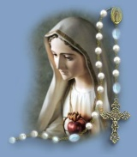
Our Goal is $45,000.00
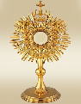
St. Clement Parish at 409 Markland Drive, invites you to drop in at their Adoration Chapel.
It is open daily from 6am to 12midnight.
You are also welcome to sign up as Permanent and/or Substitute adorers.
For more information, please call Elizabeth at 416-621-4060

Vocations - Ordination
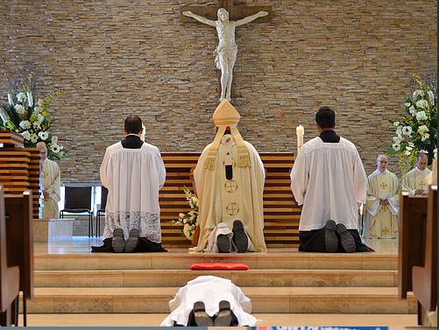
Let us pray for our newly ordained priests that Jesus will fill their hearts with faith, hope and love.
We pray to the Lord.
Glory to the Father and to the Son and to the Holy Spirit. Listen to what Jesus says: "When the Spirit of Truth comes, he will guide you into all the truth." What is the 'truth' of your life? How can you best serve God? If you think God is calling you to be a priest, religious or deacon,
contact Fr. Chris Lemieux, Vocation Director, Archdiocese of Toronto 416-968-0997
www.vocationstoronto.ca

Crowning of Mary on Wednesday May 25th at 7:00 p.m.
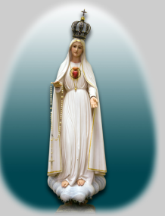
As in the past years we will crown our lady. Please bring one rose.
In case you cannot bring a rose there will be plenty at the back of church.

PRAYER
O Virgin Mary, my Mother,
I give to your Immaculate Heart
my body and my soul,
my thoughts and my actions.
I want to be just what you want me to be,
and do just what you want me to do.
I am not afraid because you are always with me.
Help me to love your Son, Jesus,
with all my heart and above all things.
Take my hand in yours, so I can always be with you.
Amen.
The month of May is dedicated to Mother Mary.
.
March for Life on Thursday May 12
was a huge success, 20,000 plus! The Knights of Columbus, the Catholic Women's League of our parish, along with a number of generous parishioners, financially supported the Right to Life bus to Ottawa. A number of our parishioners were on the bus.
Right to Life is very grateful for your support and attendance and thank you for all your prayers.

Mass | Intentions
Tue May 24
9:00 am
Wed May 25 | St. Bede the Venerable, Priest and Doctor of the Church
9:00 am | †Nicola & †Franco Torres
7:00 pm | †Emma Pozzi
Thu May 26 | St. Philip Neri, priest
9:00 am
Fri May 27 | St. Augustine of Cantebury
9:00 am
7:00 pm | †Guido Testa
Sat May 28
9:00 am | †Angela D'Amelio
4:30 pm | †Anne Ruja
Sun May 29 | Corpus Christi
9:00 am | Thanksgiving req. by Monika Kiklas
11:00 am | †Joan Campbell
Pray for the sick of the parish, especially for:
Donna Wilson, Jane Murnaghan, Mary Bergin,
Gladys Smyth, Anne English, Anita Bergin, Viola McLaughlin, Ada Ottolino, Fred Micallef, Susie Zahra, Marcelle Caruana, Arduino Bonora, Maria Vella,. A. Matar.

Holy Trinity
All hail, adored Trinity:
All praise, eternal Unity:
O God the Father, God the Son,
And God the Spirit, ever One.

Three Persons praise we evermore,
And thee the Eternal One adore:
In thy sure mercy, ever kind,
May we our true protection find.

O Trinity, O Unity,
Be present as we worship thee;
Ant to the angels' song in light
Our prayers and praises now united.

Praise God, from whom all blessing flow
Praise him, all creatures here below;
Praise him above, ye heavenly host:
Praise Father, Son and Holy Ghost.

Pray for the Church - by Pope Francis
Let us ask ourselves today: how much do I love the Church? Do I pray for her? Do I feel part of the family of the Church? What do I do to ensure that she is a community in which each one feels welcomed and understood, feels the mercy and love of God who renews life? Faith is a gift and an act which concerns us personally, but God calls us to live with our faith together, as a family, as Church.
Let us ask the Lord... that our communities, the whole Church, be increasingly true families that live and bring the warmth of God.

