4th Sunday of Lent
March 6-2016 Year "C"
Stations of the Cross every Friday after 7:00 p.m. Mass

"This brother of yours was deead, and has come to life." Luke 15.1-3
Sts. Martha and Mary website: office@stsmarthaandmary.org
This gospel about the merciful father and his two self-centred sons is one of the best loved stories in the scriptures. The young, a wastrel, tells us something about greed and its consequences but also about the virtues of humility and repentance. The elder, a complainer, speaks multitudes about human nature and how easily envy, jealousy and resentment arise when other people are treated well. The younger son, in a hurry to meet life, gets what he can out of his father, gathers together his bits and pieces and off he goes to live it up and do his own thing. When the money runs out his friends leave him and he finds himself reduced to living like and animal. Down in his luck, he comes to his senses and realizes he has made a fool of himself. Hoping for forgiveness, he heads back home to face his father and is overcome with the welcome he receives. The older son,, a solid citizen who had never put a foot wrong in life and is resentful of his brother's notorious living, cannot come to terms with the easy pardon and refuses to join the celebrations. His type would never have experienced the shame of coming home in disgrace, knowing full well that the tongues of the town were wagging and buzzing with gossip.

Lent is a time for growing in an appreciation of the beautiful and comforting truth that every person has a place in the heart of God. This story is drawn from real life with existing situations and if we are honest we can see shades of the elder and younger sons in ourselves.

of why God gave us life. The challenge confronting us is to hoe the ground around our hearts in the expectations that it will produce good fruit.

Mass | Intentions
Mon Mar 07 | St. Perpetua & Felicita, martyr  No Mass | Req. by
Tue Mar 08 | St. John of God, religious
9:00 am
Wed Mar 09 | St. Francis of Rome , Religious
9:00 am
7:00 pm
Thu Mar 10
9:00 am
Fri Mar 11
9:00 am
7:00 pm | †Ettore Mazzei (1 Month) | Family
Sat Mar 12
9:00 am
4:30 pm | †John Borg | Maria Borg Fam.
Sun Mar 13 | 5th Sunday of Lent
9:00 am | Pro Populo
11:00 am | †Diamantino Miguel  †Mauro Tita  †Bruno Fortunato | Reynolds Fam.  Tita Fam.  Tita Fam.

.To request a Mass simply phone the office and
place stipend with all particulars in the regular collection. Thank you.

Pray for the sick of the parish, especially for:
Donna Wilson, Jane Murnaghan, Mary Bergin,
Gladys Smyth, Mary Pennell, Anne English, Anita Bergin, Viola McLaughlin, Ada Ottolino, Fred Micallef, Sharon Cardinal, Susie Zahra, Marcelle Caruana, Arduino Bonora, Maria Vella.

We are still collecting items to send to the Leper Colony in the Philippines. The sisters ask for help with linens i.e. sheets and table cloths and towels, as well as white tee-shirts.
We just finished sending four more boxes. Two more boxes are ready to ship. Thank you so much.

Next CWL meeting March 14 at 7:00pm.
V o c a t i o n s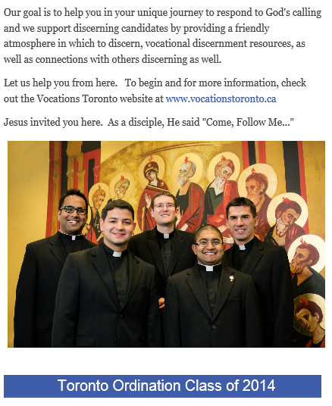
Contact Fr. Chris Lemieux, Vocation Director, Archdiocese of Toronto 416-968-0997
e-mail vocations@archtoronto.org www.vocationstoronto.ca

Forgiveness
Together let us pray to the Virgin Mary that she help us, Bishop and People, to walk in faith and charity, ever trusting in the Lord's mercy: he always awaits us, loves us, had pardoned us with his blood and pardons us every time we go to him to ask his forgiveness. Let us trust in his mercy!

Pope Francis

Confessions - 2016
Tuesday Mar 22
10:00a.m. to 12:00 (noon) 7:00p.m. to 9:00 p.m.
Wednesday Mar 23
10:00a.m. to 12:00 (noon) 7:00p.m. to 9:00 p.m.

Working wonders for those in our community…
“At Mary Centre, the residents of our homes have developed friendships, yet they maintain their own individuality,” says Denise Tremblett, Program Manager, “Although some of their relatives may have passed on, they love to remain active
with healthy recreational activities and visiting regularly with the rest of their friends and family members. We enjoy cooking and providing for them so they can remain at home here and enjoy their lives. We are extremely grateful that
ShareLife donors have helped to make a difference for these very special people!”
Last year, over 1,500 people with special needs received outreach services from ShareLife-supported agencies.
Sunday March 13, 2016 is ShareLife 1st collection
Please give generously. You can work wonders

Holy Week Liturgical 2016
Holy Thursday Mar 24
Mass of the Lord's Last Supper:
7:00 pm
Adoration of the Blessed Sacrament in the Chapel until
11:00 pm.
Good Friday Mar 25
Celebration of the Lord's Passion: 3:00 p.m.
Easter Vigil Saturday Mar 26 7:00 p.m.
Easter Sunday Mar 27
9:00 a.m. and 11:00 a.m.
NB Wed Mar 23 - no evening Mass

